Welcome to all IZOD IndyCar, ALMS, Indy Lights, Star Mazda,
& USF2000 Teams.

Enclosed please find necessary event information:
Stage & Wash info
Service Provider info

www.RaceOnBaltimore.com

STAGING & VEHICLE WASHING

- Vehicle staging will be set up in the same lots as last year, Lots N & O at the corner of Ridgely & Ostend Street.

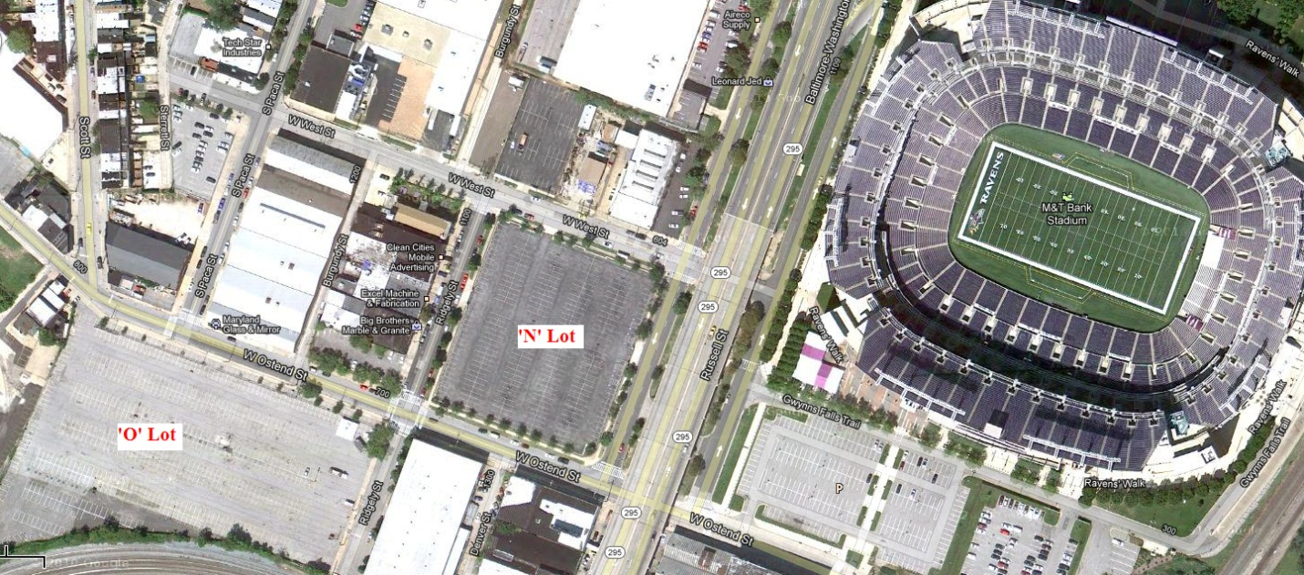

Here’s a breakdown of Staging lots & Accessibility:

O Lot: Opens 8:00 am Tuesday – IndyCar wash & stage lot. (2 wash crews) Holding Lot for Thursday move in group. If you are not moving in Thursday, please wash & relocate to the N Lot so there will be room.

N Lot: Opens 8:00 am Tuesday – ALMS wash lot during the day Tuesday, turns into IndyCar stage lot later. (1 wash crew)

D Lot: Opens 11:00 pm Tuesday – Mostly used for ALMS series staging and overfill parking.

Directions:
Take I-295 North toward downtown Baltimore
Turn right onto Worcester St.
Left on Warner St.
Left on W. Ostend St.
Lot D ALMS staging lot will be located on your immediate right.
Lot N will be up on your right.
Lot O will be up on your left.

Move In Schedule:
Teams & Manufacturers refer to Final track schedule.
IndyCar Team Hospitality & Driver Coaches will move in following the conclusion of the 12:35 start Orioles game on Thursday. We are hopeful of an earlier start time than last year.

Service Information:

Tent/table/chair Contractor: Select Event Rentals
Phone: 410 653 6851
Carmen Trimboli ext. 4118 ctrimboli@weparty.com
Or Vicki Rathell ext. 4175

Golf carts: The Golf Car Company
800-589-8833
reservations@golfcarcompany.com

Porta-let & Pumper service: Don’s Johns - Finley Revels
Direct: 703-273-7101
Mobile: 703-856-0776
frevels@donsjohns.com

Security Contractor: Tim Westhoff
BCM Solutions, Inc.
Phone: 570.704.0625, ext. 309
timw@bcminc.us

Phone and Internet: Separate order form

Truck Wash Crew Early Jackson
817-707-9056
Anointedautodetail48@yahoo.com

Credentials Location: Marriott Inner Harbor Camden Yards
110 South Eutaw St.
Baltimore, MD 21201
Hotel Phone# 410-837-8336
Deliveries:
No deliveries will be permitted during on-track race activities (8 a.m. – 5 p.m.). Vehicle access for all deliveries will be permitted after the day’s on-track events are completed where access is possible. Teams who wish to have items shipped to the track, may do so by including the proper contact information on all shipping labels and shipping to the following address. This will be the main weekend drop off for Fed-EX/UPS.

Grand Prix of Baltimore Label Information:
M&T Bank Stadium Team/Organization
1101 South Russell St. Series or Affiliation
Baltimore, MD 21230 Contact Name & Phone Number
Phone: 443 759 4301

LIGHT RAIL Users – Note:
The MTA Light Rail Service does NOT start until 11:00 AM on Monday September 3, 2102. This was an issue last year because a lot of the teams wanted to use the Light Rail to get to BWI airport on the Monday after the Race Event ….but it is Labor Day, so it doesn't start running until 11:00 AM.

